

Placement test for math level 2-3-4.

1. (2) If you know the total number of dots, can you tell how many dots are covered by rectangles? Why do you think so?



________________________________________

________________________________________

________________________________________

1. (2) Calculate:

|  |  |  |
| --- | --- | --- |
| $$12+4=$$ | $$6+7=$$ | $$5+8=$$ |
| $$16-6=$$ | $$17-10=$$ | $$12+7=$$ |
| $$0+14=$$ | $$20-0=$$ | $$9+10=$$ |

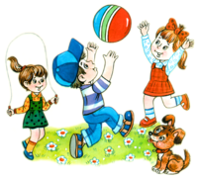

1. (2) 4 boys and 5 girls were playing in a yard. After a while 6 of them went home. How many children did remain in the yard?

_______________________________________

_______________________________________

_______________________________________

4. (2-3) According to the equality below which of the three positive numbers (☼, ☺, 10) is the biggest?

$$☼-10=☺$$

a. ☺ b. 10 c. ☼ d. Impossible to conclude

Which is the smallest?

1. ☺ b. ☼

5. (2) Fill in the missing numbers:

|  |  |  |
| --- | --- | --- |
|  |  |  |
|  |  |  |

6. (2) Circle the cup that has red figures and circles.

7. (2-3) Solve the following equations:

|  |  |  |
| --- | --- | --- |
| ______________________  ______________________  ______________________ | ______________________  ______________________  ______________________ | ______________________  ______________________  ______________________ |

8. (3) a. There are *x* books on the first shelf. There are *y* books on the second shelf. How many books are on both shelves?

*A) z B) x + y C) x – y D) x × y E) x ÷ y*

b. There are *a* cookies in one box. In another box there are 2 cookies more than in the first. How many cookies are in both boxes?

*A) a + 2 B) b C) a + a + 2 D) a × 2 E) a ÷ 2*

9. (3) Name the biggest and the smallest three-digit numbers.

______________________________________

10. (3) Lisa picked 10 flowers out of 9 chamomiles, 2 lilies, and 3 dandelions into a bunch. Are there any chamomiles in the bunch?

______________________________________

11. (3) Calculate:

|  |  |  |
| --- | --- | --- |
|  |  |  |
|  |  |  |

12. (3-4) John, Mary, and Peter went fishing. John caught 15 fish, Peter caught 3 times less than John, Mary caught 2 fish fewer than John and Peter combined. How many fish did the three of them bring home together?

__________________________________________________________________

__________________________________________________________________

__________________________________________________________________

13. (4) Calculate:

|  |  |
| --- | --- |
|  |  |
|  |  |

14. (4) Find the area of the blue figure.

a. b.

area.wmfarea2.wmf

15. (4) Solve the equations:

|  |  |
| --- | --- |
|  |  |

16. (4) Calculate:

|  |  |
| --- | --- |
| a. | b. |

|  |  |
| --- | --- |
|  |  |

17. (4) Meet Little Joe and Foxy Tail! Foxy Tail always lies and Little Joe always tells the truth. Once they said:

**FT: My brother Little Joe likes milk.**

**LJ: My brother Foxy Tail likes milk.**

Which of the brothers does like milk?

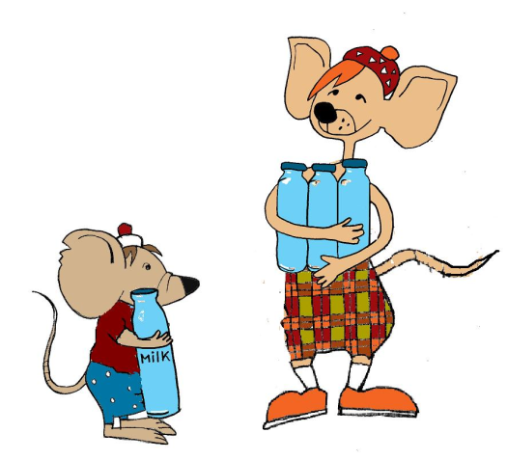

18. (4) Based on the picture below:

stets.wmf

Can you connect figures and the words these figures represent?

terms.wmf bulldogs

mammals

dogs